*This quick lesson assumes you have already created your divs for your website. Use your notes from “****Creating a CSS Rule”*** *(Assignment 4-2) and “****Positioning with a Div****.” (assignment 5-1)*

**Placing a picture**

1. Make sure you are in the ___________________________________________
   1. 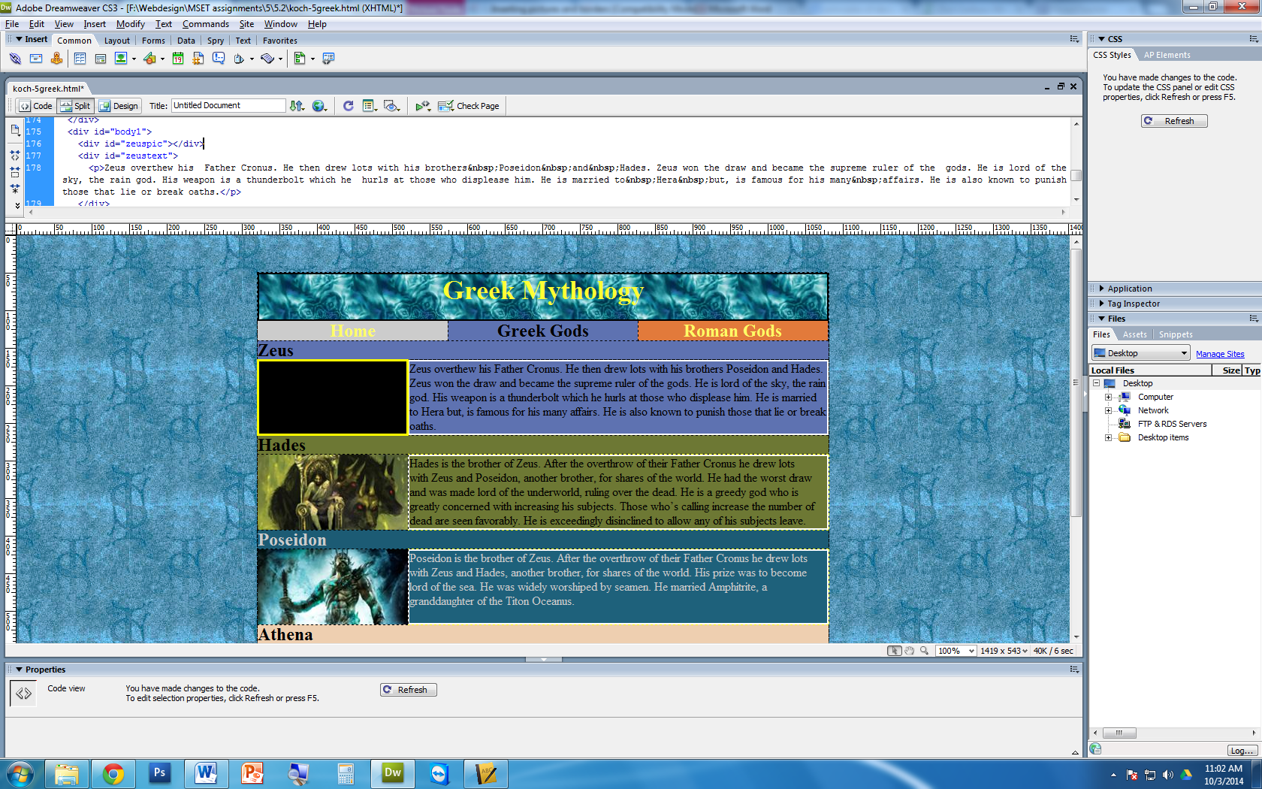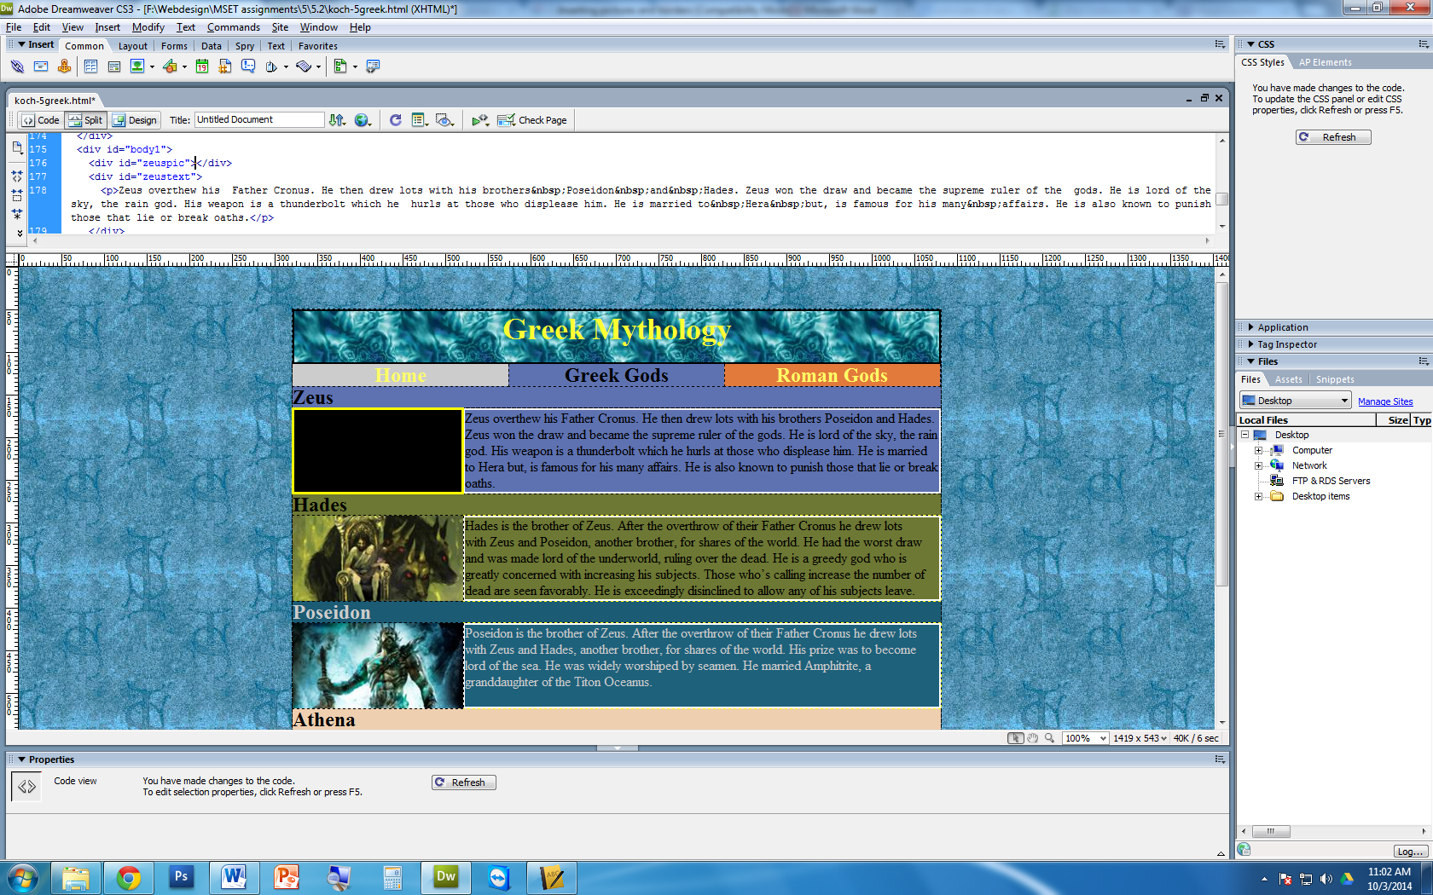 (circle the correct picture)
2. 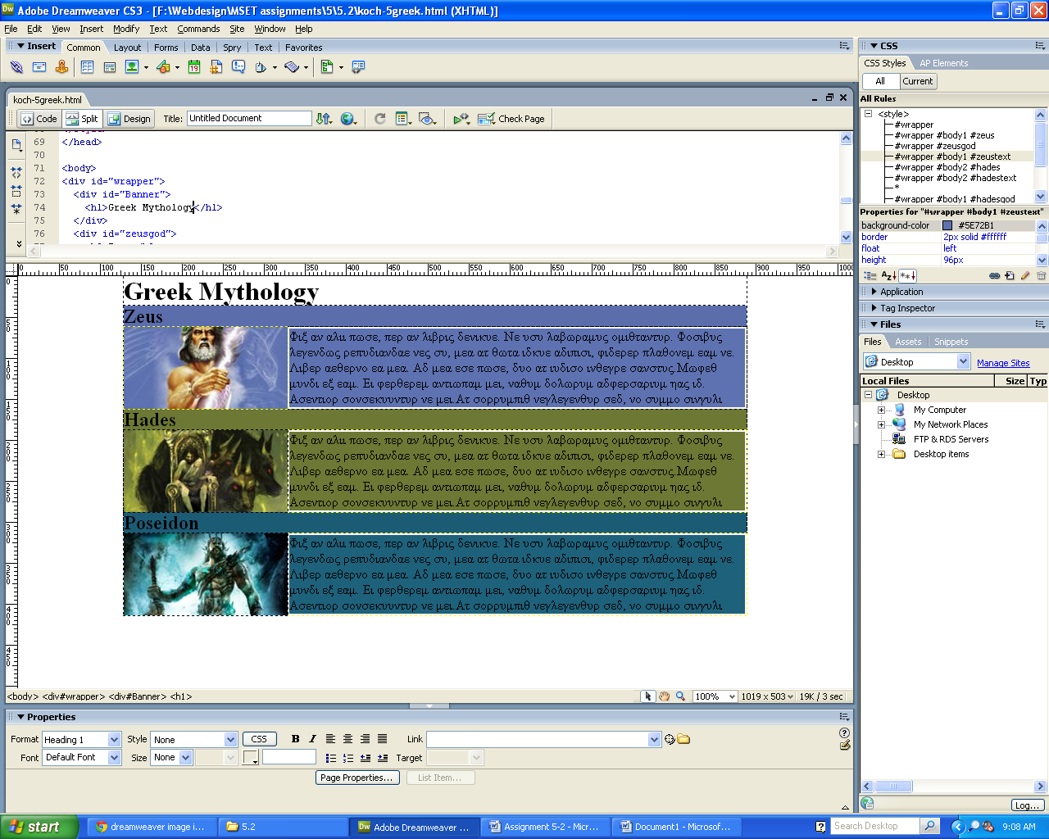Click on the   
   image icon
3. Locate your picture. Make sure your pictures are____________
   1. If not, what will happen when you place it on the T: Drive?
   2. Add alternate text

**Adding a border through CSS Rules (for assignment 5.2)**

*In your* ***CSS rules****, we need to change a few things. Double click on your CSS Rule in your CSS window.*

1. In the ___________________ tab
   1. Create the style. (same for all)
      1. Create the ___________. We will use _____ for this assignment
   2. Create the color. (same for all)
2. What happens to the div?
3. In the _________________ tab
   1. Change the height and width
      1. **MATH QUESTION:** If we have a width of 2 pixels on each side of our div, how much do we have to reduce the height and width css rule?   
          Answer: _____ x ______
   2. What is the height and width of our div **without** the border? ____x_____
   3. What is the final height and width of our div **with** the border? ____x_____
      1. This is the height and width we have to adjust in the CSS rules